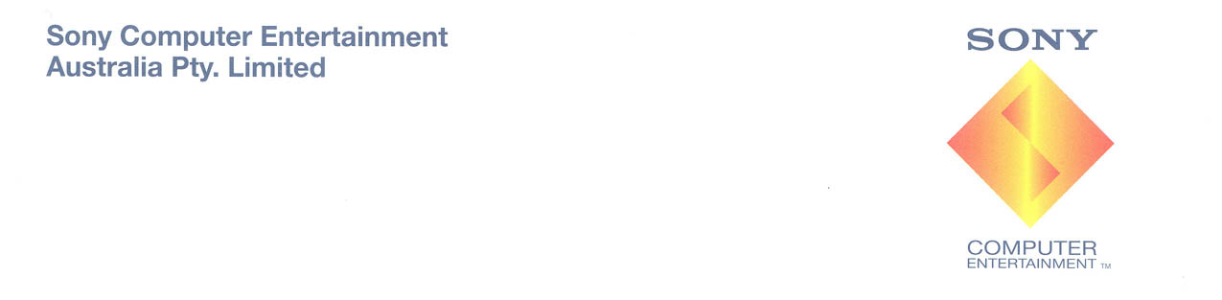

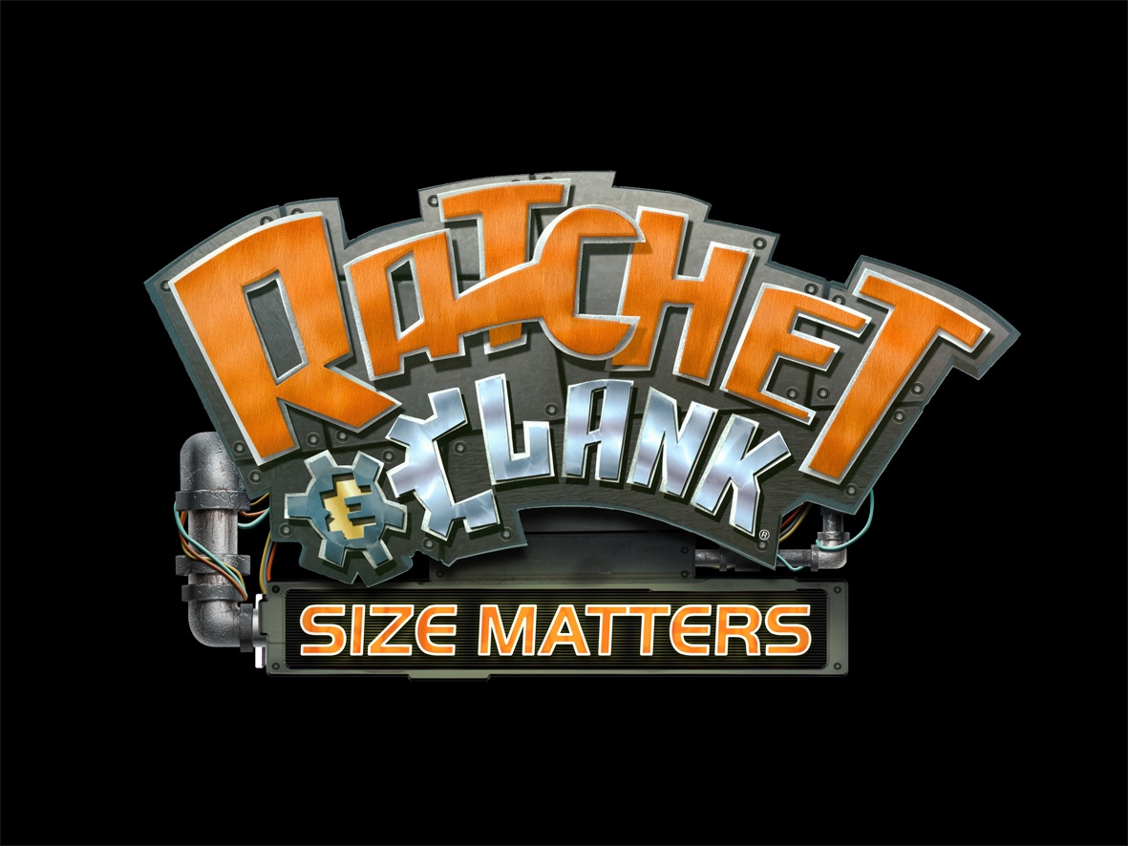

SYDNEY, May 2007 – Sony Computer Entertainment Australia is pleased to announce Ratchet & Clank™: Size Matters, an all-new sci-fi action adventure made exclusively for the PSP® (PlayStation®Portable). Featuring many new and returning weapons and gadgets, Ratchet & Clank™: Size Matters will draw players into a galaxy spanning adventure set across new levels with diverse gameplay.

As the first title developed by High Impact Games, Ratchet & Clank: Size Matters goes back to the franchise’s roots with hallmark Ratchet & Clank gameplay sure to please fans of the series. Ratchet & Clank: Size Matters features all new gameplay for Ratchet’s brainy robotic sidekick, Clank, who steps out from behind the shadows to assume a prominent role alongside Ratchet. Re-capturing the humor from previous PlayStation®2 installments, Ratchet & Clank: Size Matters will allow up to four players to blow one another away in action-packed wireless multiplayer gaming.

While on a much needed vacation, Ratchet and Clank’s rest and relaxation time is suddenly cut short as they soon find themselves lured into a mysterious quest. Following the trail of a kidnapped girl, Ratchet and Clank rediscover a forgotten race of genius inventors known as the Technomites. They soon uncover a plot more dangerous than they could have imagined!

KEY FEATURES
- Ratchet and Clank make their PSP debut, going back to the franchise’s roots with classic Ratchet & Clank gameplay. Play through an original story and explore all new worlds, specifically designed for the PSP.
- Clank returns as a playable character, and players can control the gadgebots, pilot super-sized robotic torsos and engage in space combat missions as Giant Clank.
- Experience all of the combat and destruction fans have come to expect from the series with new and familiar weapons and gadgets including the Mootator, Agents of Doom and Shrink Ray.
- Unlock over six different armor types with a customizable armor system that gives Ratchet new abilities and powers to advance through challenging action-packed areas.
- Tear up the track in Intergalactic Hover-boarding and struggle for Clank’s survival in all new Combat Arena missions.
- Compete with up to four players using wireless multiplayer gaming via Ad-Hoc or Infrastructure mode. Challenge opponents in the objective-based Iron Lombax mode or in fast-paced battles such as Capture the Flag and Deathmatch.

###

Release Date: 24 May 2007
Developer: High Impact Games
Price: $79.95 RRP
Rating: PG
Platform: PSP® (PlayStation®Portable)

For further information on PlayStation products, go to www.scee.presscentre.com/au

Anna Donnison  Hausmann Communications  P: 02 8353 5749  E: anna.donnison@hausmann.com.au | Nicole Kennedy  Hausmann Communications  P: 02 8353 5714  E: nicole.kennedy@hausmann.com.au

About Sony Computer Entertainment Europe Ltd.
Sony Computer Entertainment Europe (SCEE), based in London, is responsible for the distribution, marketing and sales of PlayStation®2 and PSP® (PlayStation®Portable) software and hardware in 102 territories across Europe, the Middle East, Africa and Oceania. SCEE also develops, publishes, markets and distributes entertainment software for these formats, and manages the third party licensing programs for the formats in these territories. Between its European debut on 24th November 2000 and the end of September 2006, over 42 million PlayStation 2 consoles have been shipped across the SCEE territories, over 111 million worldwide, making it one of the most successful consumer electronic products in history. Between its European debut on 1st September 2005 and the end of September 2006, over 8 million PSP systems have been shipped across the SCEE territories, with over 22.9 million shipped worldwide since its Japanese launch in December 2004.

About Sony Computer Entertainment Australia
Sony Computer Entertainment Australia (SCE Aust.) is responsible for the distribution, marketing, sales and network support of PlayStation®2 and PSP® (PlayStation®Portable) software and hardware in Australia and New Zealand. SCE Aust. commenced trading in Australia in 1995. At the end of September 2006, over 2.7 million units of PlayStation®2 consoles and 300,000 PSP® units had been shipped across Australia and New Zealand.

More information about PlayStation products can be found at www.playstation.com.au or visit the Virtual Press Office at www.scee.presscentre.com/au

PlayStation, PSP and the PlayStation logo are registered trademarks of Sony Computer Entertainment Inc. UMD (Universal Media Disc) is a trademark of Sony Computer Entertainment Inc. All other trademarks are property of their respective owners.

